Logic Design

EECS101001

Lab 4: Matrix Operations – Report

104021215 熊 磊

**Matrix Operator**

1. Foreword

This Lab is trying to implement a matrix operator. Finally we will get **Y = AX+B**; size of Y is *n x n*, size of A is *n x r*, size of X is *r x n*, and size of B is *n x n*.

The input includes **clk**, **reset** and **in_data**, while the output includes index of the matrix we want to read, function choice, out_data and finish.

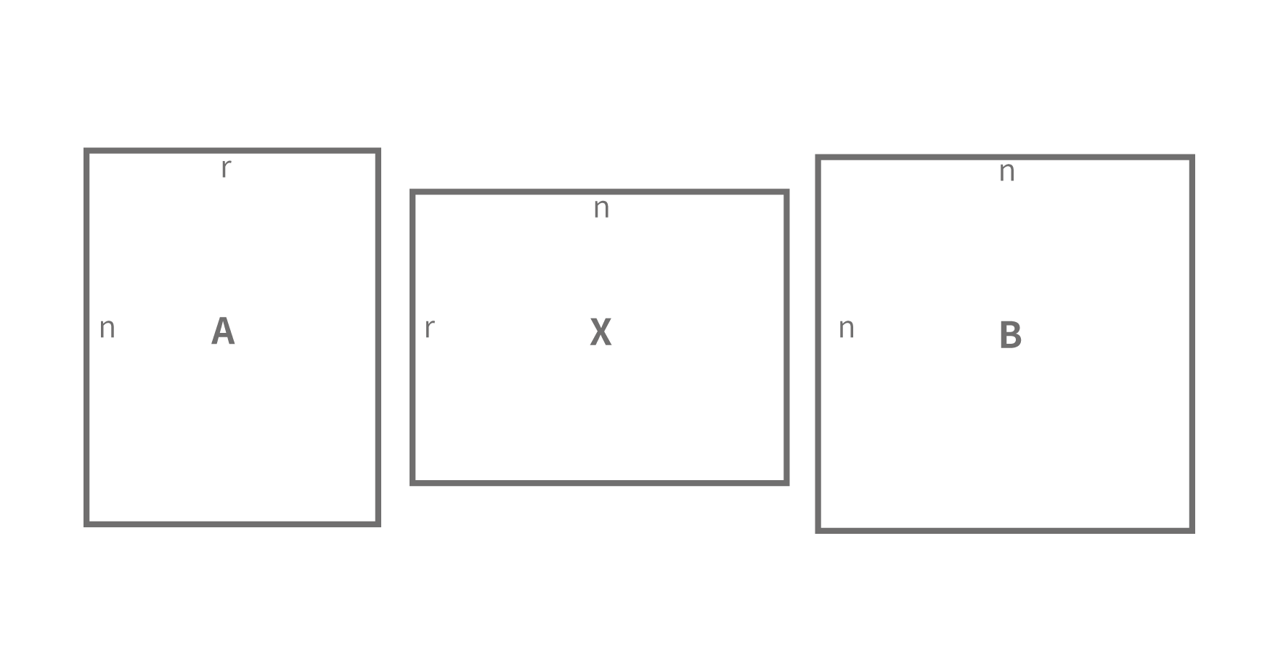

### Input

|  |  |  |
| --- | --- | --- |
| **name** | **width** | **function** |
| clk | 1 | 時間訊號 |
| reset | 1 | reset=0 進行reset |
| in_data | 10 | 讀取的資料 |

### Output

|  |  |  |
| --- | --- | --- |
| **name** | **width** | **function** |
| i | 10 | row index 0<=i<=9 |
| j | 10 | column index 0<=i<=9 |
| opcode | 3 | 控制讀寫 |
| out_data | 20 | 輸出的資料 |
| fin | 1 | 結束時讓 fin=1 |

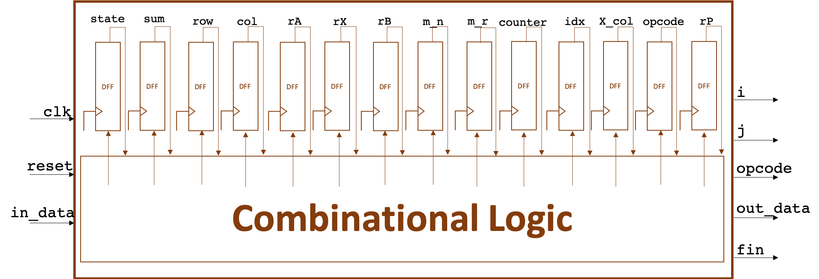

1. Implementation Details and Designs

First, we draw a State Transition Graph as Follow:

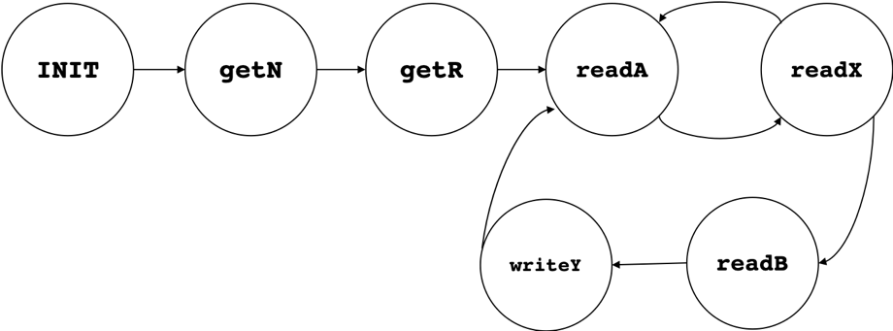

We need at least 7 States to detect the pattern, hence we must define states with at least 3 bits.



Note that we have to design an independent DFF outside the MO module. And this time we need many DFFs to store lots of data, it will be introduced in detail later.

In the beginning, first **negedge** will get **reset = 0**. And we set **next_state** to **INIT** when **reset == 0**.



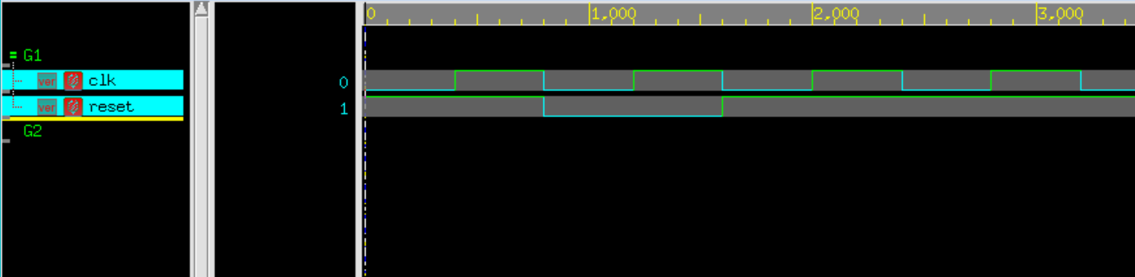

Now we determine when to change states, and to which state.



Note that **counter** is used to count how many times that matrix A and matrix X have been read. When it read **2*r** times, which means it had completed once inner product computation, ready to add the value of matrix B, and was going to change state to **readB**.

In each DFFs, it stores lots of data, and, also, control the main operation. The function of each wire is as follows:

|  |  |
| --- | --- |
| **wire** | **function** |
| state | Transmit the current state, initial will be **INIT**. |
| sum | Transmit the sum of inner produce of A and X, when state is **READ_A** and **READ_B**. And it will reset to 0 in state **WRITE_Y** and **INIT**. |
| row | Transmit the row index of A. When it finishes r times inner product for each column in X, row index will increase by 1. |
| col | Transmit the column index of A. When it finishes once element multiplication of inner product, col index will increase by 1, and it will reset to 0 when it finishes once inner product of each colume in state **WRITE_Y**. |
| rA | Transmit the value of A[row][col]. |
| rX | Transmit the value of X[col][X_col]. |
| rB | Transmit the value of B[row][X_col]. |
| rP | Transmit the value of correct rA that is going to be multiply by rX. |
| m_n | Transmit the row size of matrix A. |
| m_r | Transmit the column size of matrix A. |
| counter | Transmit the times that read in matrix A and matrix X. And when it has read 2r times, finished once inner produce of matrix multiplication, it will reset to 0. |
| idx | Transmit the turns that whether matrix A or matrix X take. 0 is for matrix A, and 1 is for matrix X. |
| X_col | Transmit the column index of X. |

Hence, we can do the matrix operation!

**Systolic Array**

1. Forewords

This lab is going to design a 4x4 multiplication using systolic array. The idea is very simple, systolic array has a network of tightly coupled data processing units (DPUs), say nodes. Each node independently computes a partial result as a function of the data received from its upstream neighbors, stores the result within itself and passes it downstream.

For this lab, the input will come from a1~a4, b1~b4. And output will toward c1~c16. We draw a simple diagram below, and we are ready to design.

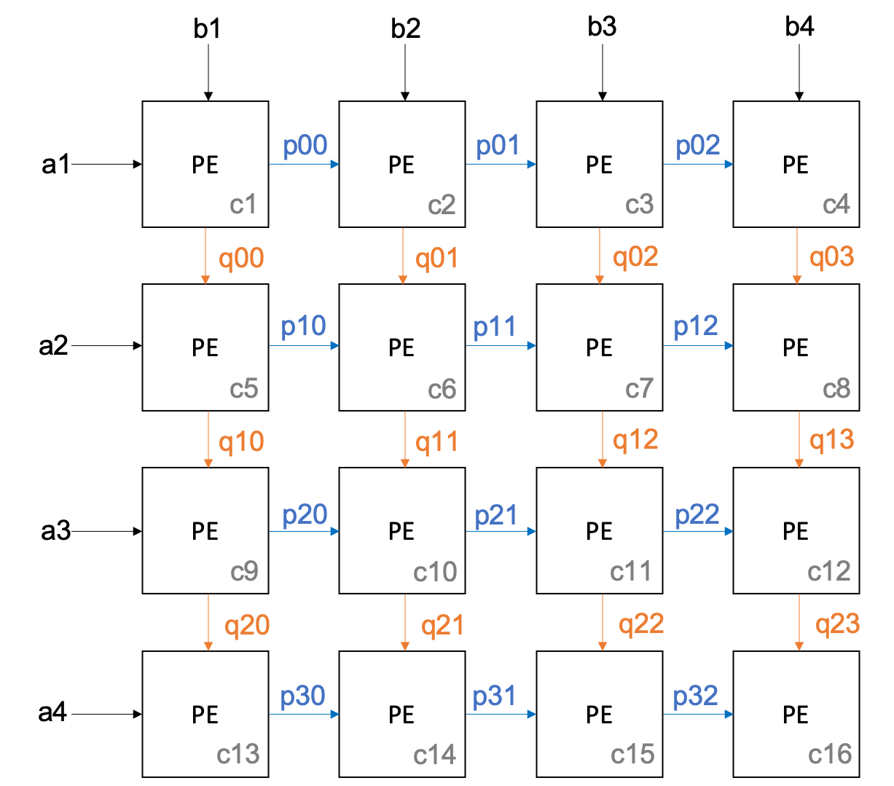

Where the design of Processing Element (PE) we use here is

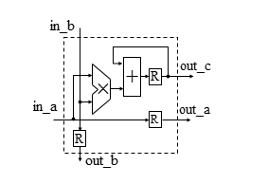

Hence, the PE can be described like this:



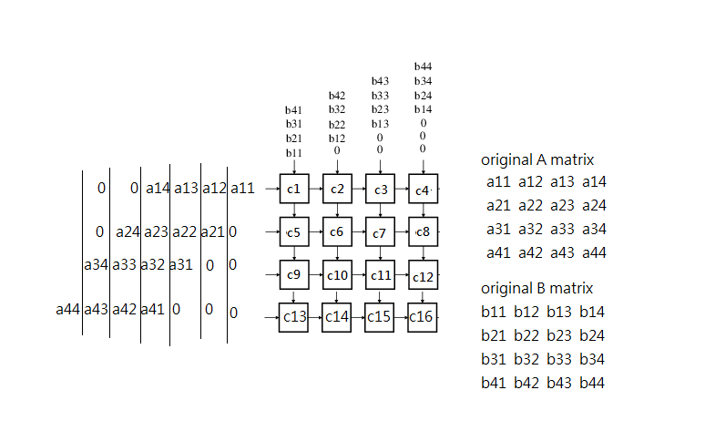

In SA module, we can instantiate 16 PEs and wait for 11 cycles, it will finish N3(= 43) multiplications.



1. nWave Result

Matrix Operator

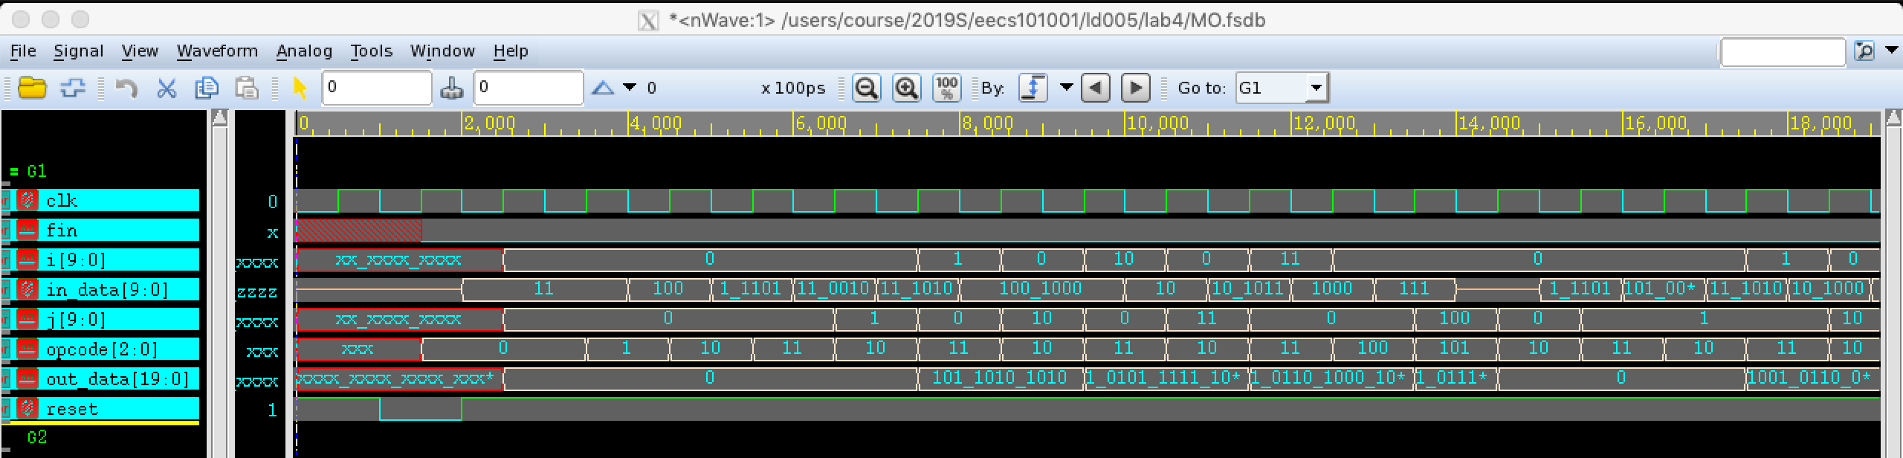

Systolic Array

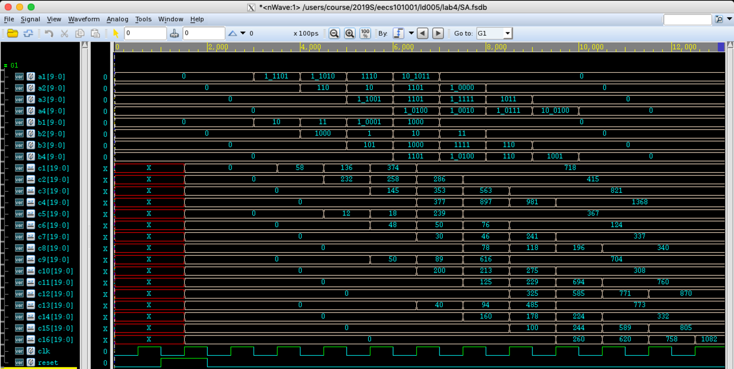

1. Report Area

Matrix Operator Systolic Array

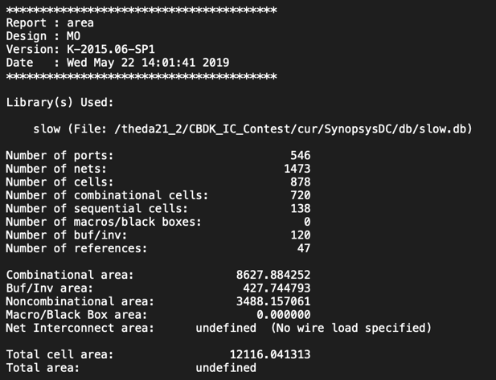 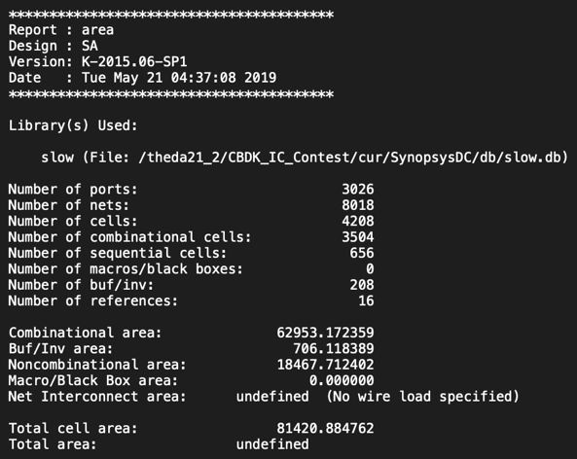

1. Encountered Problems and Solving

* In this lab, we have to be very careful in handling row index and col index.
* Also, determine when to change state from **READ_X** to **READ_B** is important, here I use counter for help.
* In systolic array, we can do more thing in same limited time, helping us increasing throughput. However, it needs more costs in space and money.

1. Questions

* This time the lab is very interesting. Most problem have been figured out on my own!

1. Impression and Experience

Finite State Machine is very powerful and also amazing. Everything if we can present in FSMs, then we can describe clearly! Also, thank to TAs, the end of the semester is coming, you did a great job! ☺